

**Hospital’s Name**

MEDICAL RECORD APPLICATION FORM

|  |
| --- |
| **Patient’s Personal Data** |
| Prefix / Position....................... Name............….................................................................................................. Gender  Male  Female Passport Number / Expatriate............................................................................ Date of Birth............................. Age .................................  Marital   Single  Married  Wido  Divorced   Separate  Priest  Blood Group A B AB O/ Rh … Unknown Nationality.............................. Ethnic..……….…………..….. Religion..…………………………………...... Address …………………………………………………………………………………………………………………… District …………………….…….…....... Province.................……....................... Postal Code ……..…………… Telephone.........…………………..……….... Mobile............…................................. E- Mail ................................................... Office Address .........……………………...................…...…………………………………………………………………………………...… Telephone.........…………..……………….............……  Contract Person in case of Emergency (Please Specify) ……... Relationship Father/Mother Guardian  Child Spouse Friend Employer   Others (Please Specify)…………............. Contract Address ............................................................................ Telephone ……………………….…………. Drug Allergy  Unknown  No  Yes (Please Specify) .………………………...............................................................................................…...... Insurance Type  No Yes (Please Specify Contact Name) ....................................................................................................…………..….….... |
| I hereby certify that my personal data given to the medical record of Hospital’s Name are true and correct. I also give permission to your Hospital’s Name to take my picture in order to keep as a record and for medical purpose. If any incorrect or fault data are found, I will be solely responsible for all damages and negative consequences that may cause to any third party.  Signature……….………………………………….………..…  Patient /  Legal guardian or relative of the patient (Please Specify) .....……………..……………………….…... |
| **Consent for Outpatient Treatment/Service and Basic Rights Acknowledgement** |
| I agree voluntarily give a physician / dentist, medical staff and / or other health staff of your Hospital’s Name to examine, diagnosis, treat, perform any acts for outpatients under the medical profession and disclose my treatment information to the health care team members of your Hospital’s Name and all concerned who need to access my information. I have acknowledged the declaration of the patient’s right and duty, the right to ask about treatment, the right to know other treatment options necessary for health and the right to know the treatment result and other adverse effects. (This consent does not include an operation and other surgeries that require and additional consent.) and understand well. I have acknowledged and understand well about the patient’s right and duty declaration.  Sign ............................................................... Hospital staff Sign..............................................................Patient  (..........................................................) Date …………….………. (...................................................) Date ………..…………… |
| **In case the physical condition does not allow the patient to give consent : The information has been explained to a legal guardian in authority making decision and giving consent for the treatment.**  Name of Person in Authority ......................................................... Relativeof the Patient (Please Specify) ..................................................... Identification Card/ Driver’s License/ Others (PleaseSpecify)..............................No............................................DateExpiry........................... Address (Address ID)................................................................................................................................................................................. District................................................................................Province............................................................................... ……………………….… The reason that the patient cannot make decision by himself/herself. Below 20 Years  Other Physical or Psychological Defects........................  **Remark:** Person in authority making decision on the patient’s behalf means the legal representative of a minor (below 20 years of age or not reaching his/her legal age by registering a marriage), the curator of an incompetent person (insanity) ordered by the court of law, the quasi-incompetent person(physical disability / mental infirmity, etc.) ordered by the court of law, the spouse/ the ascendant and/or the descendant under the Civil and Commercial code. |
| **Interpretation and the Information Given by the Interpreter**  I have interpreted the letter of consent for outpatient treatment and the information explained to the patient by the physician in (language) ………..….... Interpreter’s Name..................................................... Interpreter’s Signature........................................................... Date................................ |



ตรารพ.

|  |
| --- |
| **Patient’s Right Declaration**  To ensure that the relationship between the health practitioners and the patient is on the basis of good understanding and trust, the Medical Council of Thailand, the Nursing Council, the Dental Council and the Medical Profession Control Committee jointly announce the patient’s rights as follows:  1. All patients have basic rights to receive health services under the constitution.  2. Patients have the right to receive services from health practitioners without bias regardless of their statuses, races, nationalities, religions, social statuses, political doctrines, genders, ages and characteristics of illness.  3. Patients receiving health services have the right to receive sufficient information and clear understanding from health practitioners, so that they can make decision to allow or not to allow health practitioners to act for them except an urgent or unavoidable case.  4. Patients who are in life-threatening conditions have the right to receive urgent assistance from health practitioners immediately based on the necessity of each case and whether the patients make requests or not.  5. Patients have the right to know names, surnames and types of health practitioners providing services to them.  6. Patients have the right to seek the second opinion and change the service provider and location.  7. Patients have the right to have their information kept confidential strictly by health practitioners unless consent is given by the patients, or the disclosure is made by the law.  8. Patients have the right to know all of the information for making decision to participate in or withdraw from being test samples in researches made by health practitioners.  9. Patients have the right to know about their own treatments kept at the Medical Record upon request. However, such treatment information must not violate other people’s personal rights.  10. A father, mother or legal representative can exercise the right on behalf of child patients under eighteen years of age and patients with physical or psychological disabilities who cannot exercise the right by themselves. |

|  |
| --- |
| **Patient’s Duties**  1. Fully disclose patients’ health information.  2. Cooperate in medical check-ups and surgeries.  3. Observe the rights of personnel in the organization and of other patients.  4. Comply with the policy and the rules and regulations of the organization in relation with smoking, infection control and prevention and patients’ environment protection.  5. Follow the suggestions for self care, medication usage and appointment for medical examination |

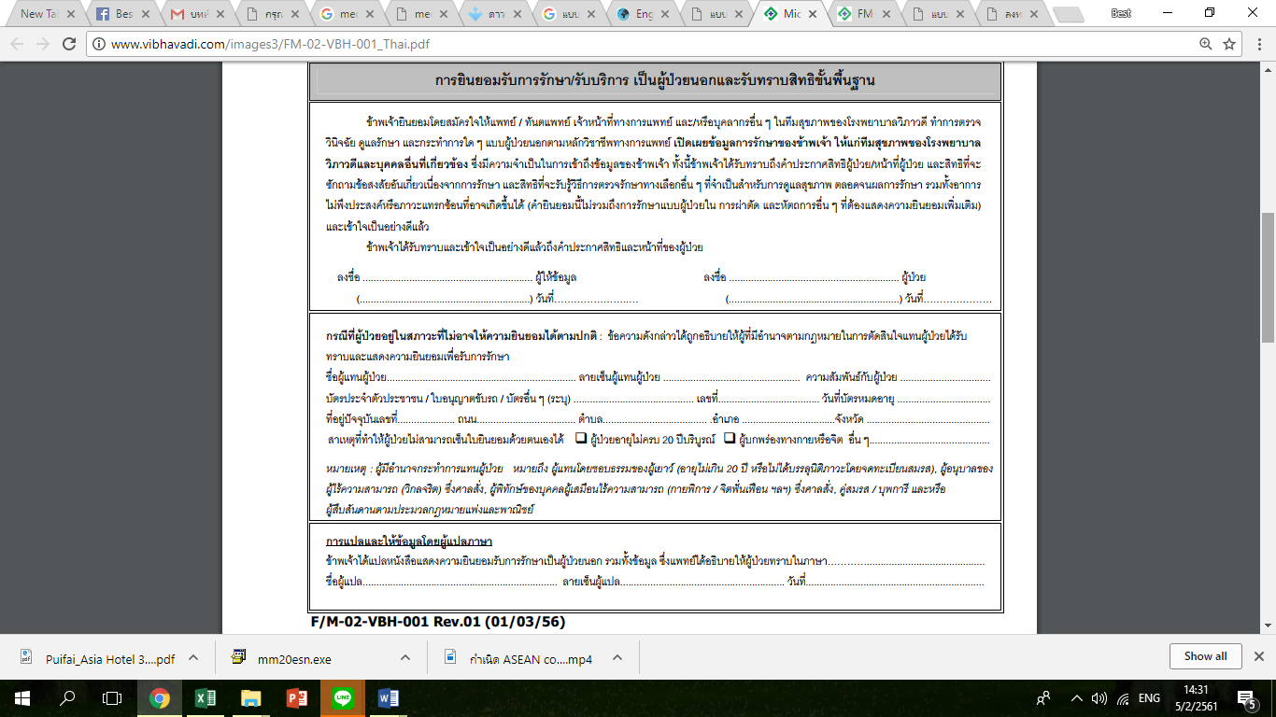

แปลแบบไทย

